**ACCESSIBILITY**

1. **Default themes:** Switch Dark/Light themes to suit your visual needs.

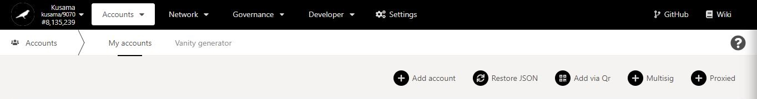

1. From the main dashboard, click on **Settings**.

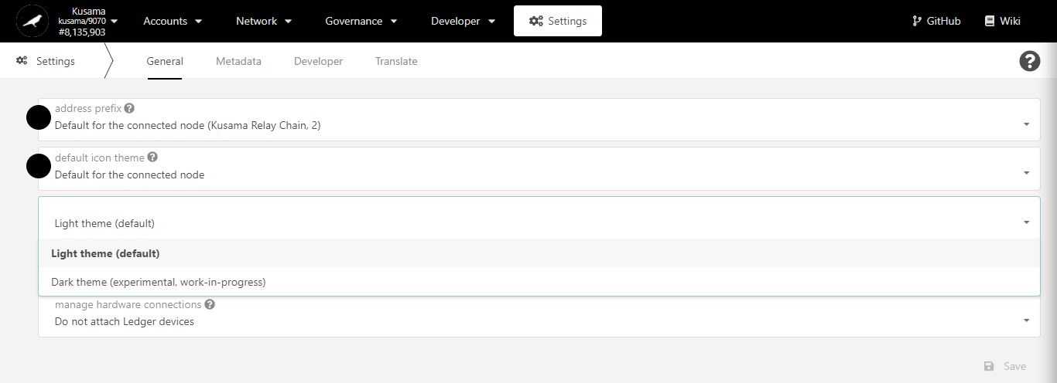

2. Select a **theme** to change the interface’s colours.

1. **Default languages:** Change the interface language to suit your translation needs.



1. From the main dashboard, click on **Settings**.

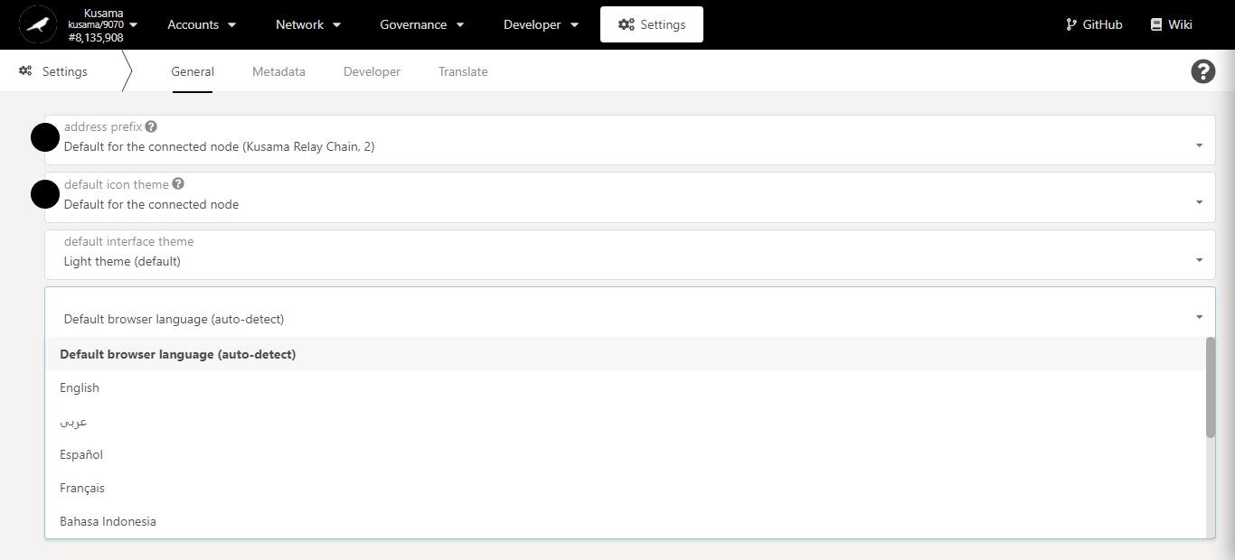

2. Select a **language** to translate the interface’s information.